

Lab 02: Hello – Your Initials

# Course Learning Outcomes

CLO 1 Describe the fundamental structures of an agent-based programming language

CLO 2 Solve a problem by using an agent-based programming language

CLO 3 Compose logical structures (algorithms) to produce an adequate solution for a problem

CLO 5 Develop and enhance problem-solving skills by applying computational thinking methodologies

# Module Learning Objectives:

1. Demonstrate usage of basic commands by creating a NetLogo program that draws their initials. (CO 1, 2, 3, 5)
2. Demonstrate positioning the turtle in the NetLogo world. (CO 1)
3. Demonstrate the usage of colors in NetLogo. (CO 1)
4. Practice utilizing turtle and observer context in NetLogo. (CO 1)
5. Utilize procedures in NetLogo. (CO 1, 3)
6. Design a NetLogo program to display the student’s initials. (CO 1, 2, 3, 5)

# ASSIGNMENT:

This assignment **used to be** to write the student’s name using NetLogo turtles, but since names vary greatly in length I want instead for the program to write the student’s 3 initials. If the student does not have 3 initials then I want the student to write 3 different letters of their choosing.

1. The NetLogo instructions for each letter should be **written in separate procedures.** This allows letters to be repeated easily if we wanted to write a word with repeated letters like the t’s in letters.
2. The “setup” button should clear the interface and create one or more turtles at specific coordinates.
3. The “go” button should call on each procedure that tells a certain turtle to draw the letters of the student’s name.

Refer to the following screen captures. (Never mind that I wrote my name rather than initials.)

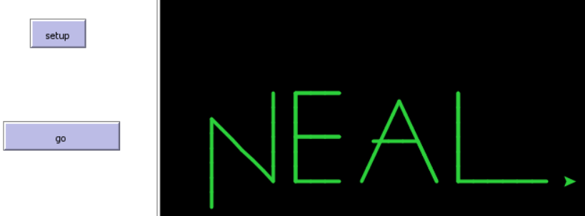

# Grading Rubric [100 points total]:

[A: 2 points]: Submit the Netlogo source file:

Name the program: lab02_hello.nlogo and submit the file to Brightspace

[B: 8 points]: Include a header at the top of the code. Refer to the following example:

; Author: **[Student’s first and last name]**

; Due Date: **[the due date]**

; Title: Lab00: Draw a Square

; School: Central New Mexico Community College

; Course Number: CSCI 1108, Section 101

; Course Title: CS for All: Introduction to Computer Modeling

; Semester: Summer 2020

; Instructor: Neal Holtschulte

[C: 15 points]: In additional to the above comments (the header), include in-line comments. In other words, include comments that summarize the purpose or result of running a procedure, or use comments to describe particular lines of code.

[D: 15 points]: IMPORTANT: Include a detailed Info tab. See the document *Coding Standards Guidelines* in Module 1 for more information. Don’t forget.

[E: 30 points]: Make sure the “Setup” button clears the world and creates a turtle, and the “go” button instructs the turtle(s) to draw the letters.

[F: 30 points]: The program draws the letters or initials (and any decorations) using at least 10 different turtle forward commands. The program may use other turtle commands.

[G: 5 extra points]: The program uses only one turtle and has separate buttons for each letter. Clicking a letter button draws the letter and leaves space so that clicking the next button writes the next letter without overlapping the first.

[H: 5 extra points]: In addition to the “setup” and “go” buttons, the program includes a third button labeled “Extra Credit”. When this button is clicked, the program clears the screen and draws a house with at least 1 window and 1 door.